**Mathematical Operation**

This document will explain how to use Run script.

Please go through the following sample automation **Mathematical operation. Zappy** file.

In this automation simply create Add, Sub, Multiply, Divide operation.

**Step 1:** Right click on Zap icon and select Task Editor (or Double click on zap icon).

**Step 2:** Open the **“Mathematical operation. Zappy”** file.

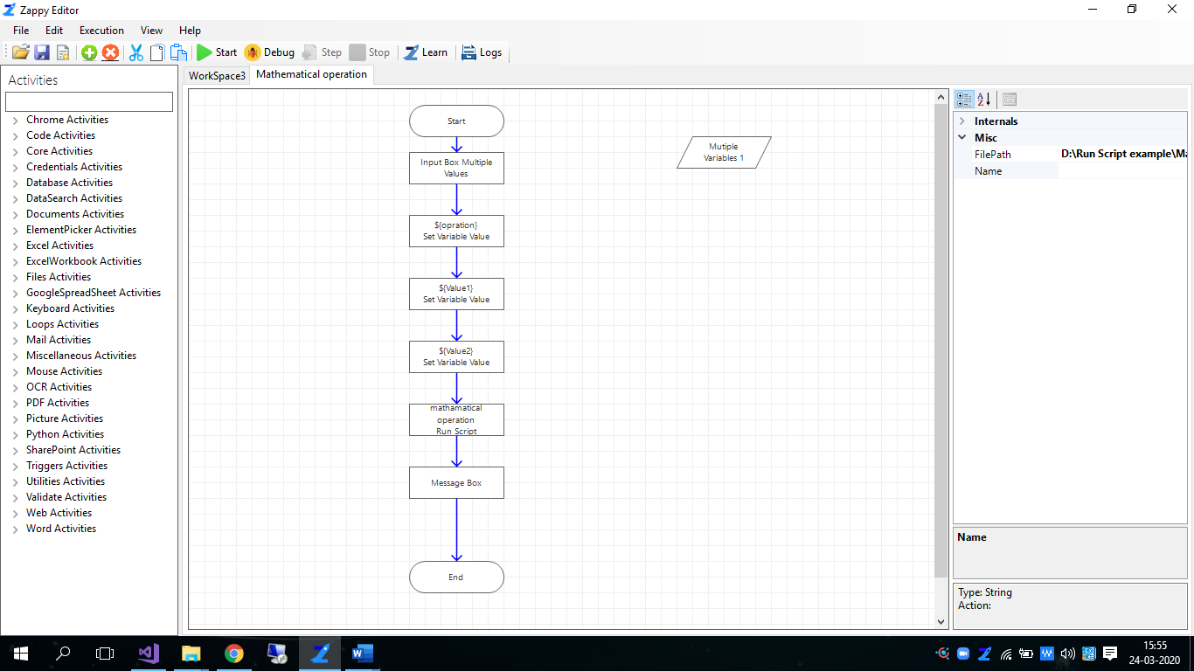

**Step 3:** To start the execution click on .

**Step 4:** Enter the required values and click on **OK** button.

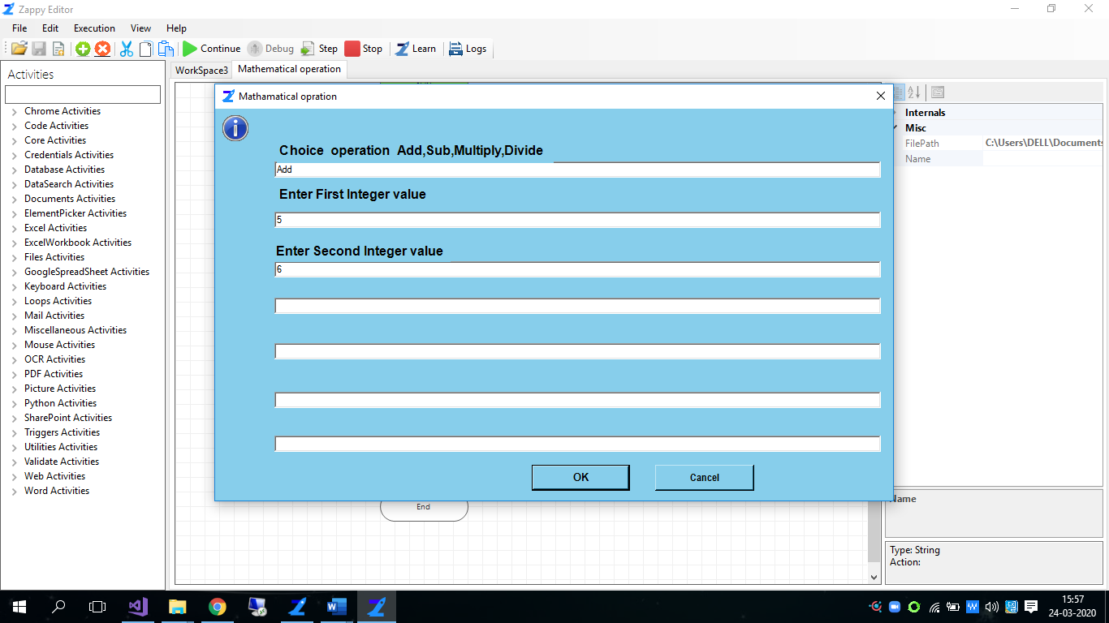

**Step 5:** Answer will be show on **Message Box** then click on **OK** button.

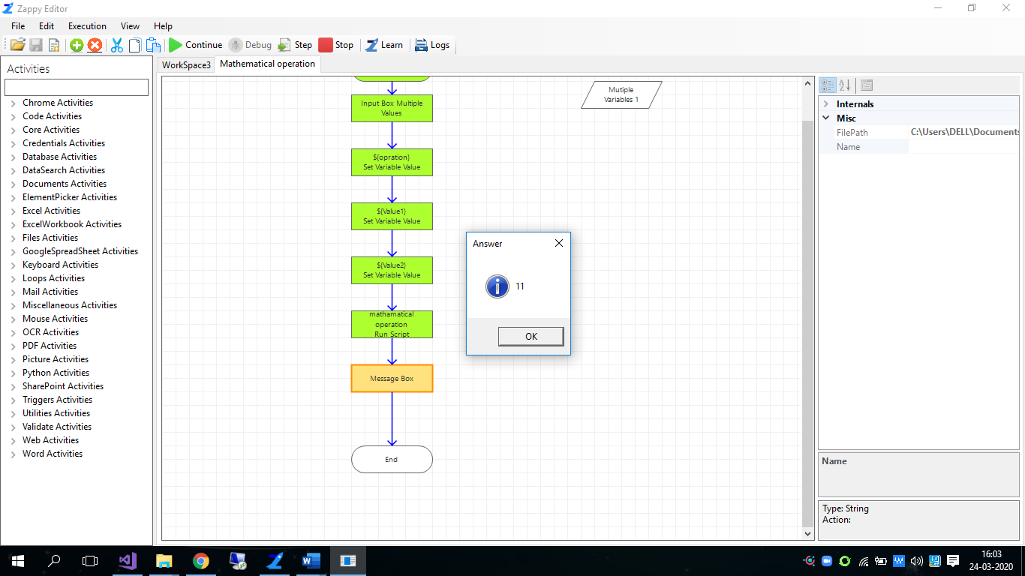

**We can execute any C# code using Run Script action.**